 



***TB and HIV Case Studies- Learner’s Handout***

In groups of 3-4, review these case studies and come up with answers to the questions as best you can using resources you may have available to you (PDA or web based).

Case Study #1:

History and Exam:

* 37 y.o. Ethiopian male presents with shortness of breath, tachypnea with marked work of breathing noted for the past 3 days. He also reports fatigue and weight loss for the past 3 months.
* 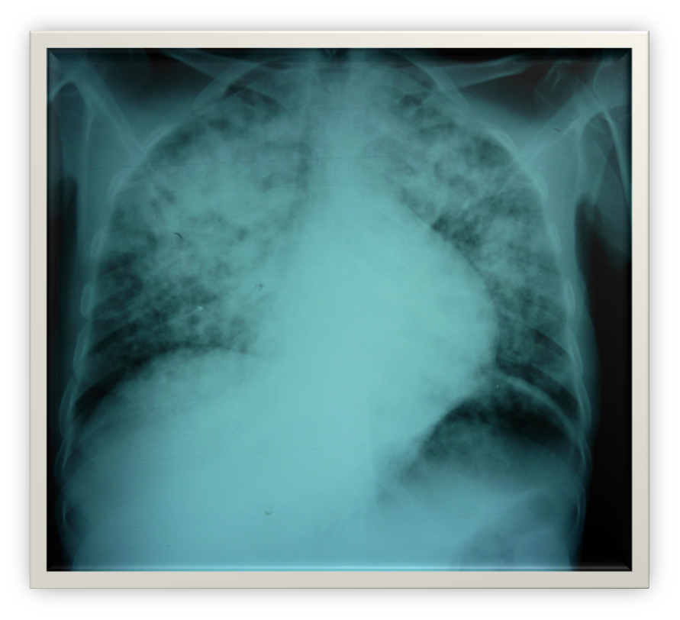Exam: afebrile, BP 90/72,P=110, RR 52, O2 sat = 41%
  + MS – arousable, not coherent,
  + Thin, wasted appearance
  + Chest – Bilateral rales
  + CV – RRR, tachy
  + Neuro – Normal DTR’s, no focal weakness or sensory changes

**What are the top 3 diagnoses on your differential?**

Group Questions:

1. What features of the history are most suggestive of TB?
2. What exam findings are most concerning?
3. How might your examination findings/vital signs inform your differential between TB and PCP pneumonia?
4. What diagnostic and laboratory studies are essential in a low resource setting to manage this patient?
5. What would you choose to begin for empiric treatment?
6. What prophylactic/preventative treatment might you include?
7. When can you start to treat HIV if the patient is HIV positive?

Case Study #2

History and Exam:

* 27 y.o. Indian male from Bangalore admitted for confusion and weight loss. Diagnosed HIV positive 3 months ago. Started HAART (nevirapine, lamovidine, abacavir) 7 days prior to admission. Fevers to 39 degrees noted. + drenching night sweats for 3 months.
* Denies any cough, SOB. + 40# weight loss over the last year. No chest pain or abdominal pain. No diarrhea.
* 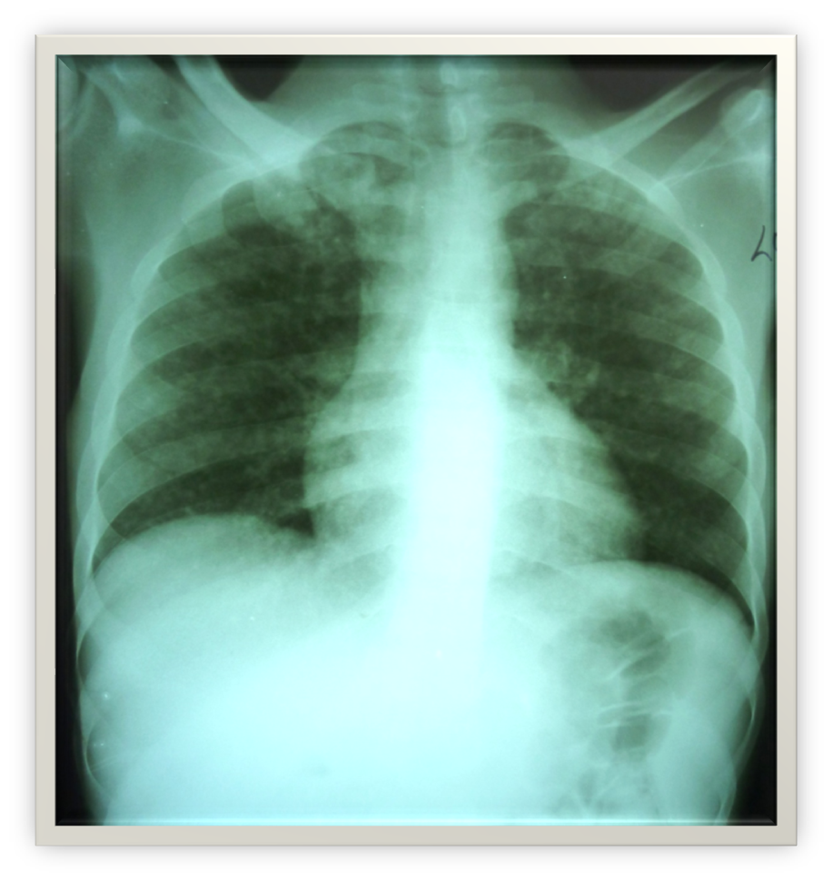Exam: Thin, male, oriented to self, place but not date/day. VS: T= 38.6, RR = 16, P = 102, BP 94/78. O2 Sat = 94%
* HEENT - + diffuse shotty adenopathy
* Chest – Clear
* CV- RRR no murmur
* Abd – soft, scaphoid
* Ext – no edema, lesions or ulcerations
* Neuro: normal reflexes, no focal deficits

Review the CXR:

Questions:

1. What concerns you about the CXR? Is there something missed on the physical exam?
2. What additional diagnosis and treatment should you consider besides TB?
3. What complications might you expect with the way this patient was initiated on HAART and not started on TB treatment prior to HAART?

Summary